**SCSJ3253**

**PROGRAMMING TECHNIQUE III**

**REPORT FOR PROJECT**

|  |  |  |
| --- | --- | --- |
| 1 | SITI NAZARIAH BINTI ABDUL RAHMAN | SX161507CSJF01 |
| 2 | MAZRIZAL BINTI ABDULLAH | SX181730CSJF04 |
| 3 | CHARLENE NG ANDREW | SX180355CSJS04 |
| 4 | NIK NUR ASHIKIN BINTI MEGAT SHAIDI | SX170113CSJS04 |

**PM DR TS MOHD SHAHIZAN BIN OTHMAN**

**Table of Contents**

|  |  |  |  |
| --- | --- | --- | --- |
| **Items** | | | **Pages** |
| 1.0 | Project Overview |  | 2 |
| 2.0 | Tools & Technology Usage |  | 3 |
| 3.0 | System Module |  | 4 |
| 4.0 | Module Functionality |  | 5 |
| 5.0 | Database Design |  | 6 |
|  |  | 5.1 Entity Relationship Diagram (ERD) | 7 |
|  |  | 5.2 Use Case | 8 |
|  |  | 5.3 Activity Diagram | 10 |
| 6.0 | Source Code |  | 11 |
| 7.0 | Interface Design |  | 17 |

1. **Project Overview**
2. **Tools & Technology Usage**
3. **System Module**
4. **Module Functionality**
5. **Database Design**
   1. **Entity Relationship Diagram (ERD)**
   2. **Use Case**
   3. **Activity Diagram**
6. **Source Code**
7. **Interface Design**
8. Project Overview

The objective of this project is to create a comprehensive platform for users to keep themselves updated with the latest news and information about FIFA World Cup Qatar 2022, as well as to provide a convenient way for them to book accommodation and purchase tickets for the event.

The FIFA QATAR website will be featuring a user-friendly interface that allows users to easily find news section, providing up-to-date information on the World Cup, including match schedules, scores, and team standings. This will allow fans to stay informed about the tournament and make the most of their World Cup experience.

The expected outcome of this project is a fully functional and user-friendly platform for users to stay informed about the FIFA World Cup Qatar 2022 and to easily book accommodation and purchase tickets for the event.

The goal of this project is to make the process of news regarding the World Cup as simple and stress-free as possible for fans, by providing a one-stop station for all their World Cup-related needs.

2.0 Tools & Technology Used

The website will be running in ASP.NET framework coded using Visual Studio platform to create a seamless and efficient user experience website.The site will be mobile-optimized, allowing users to access it easily from any device. The team provide a fully functional module that can be integrated into the website, complete with interactive features and up-to-date information on the World Cup Qatar 2022.

Front-end Framework: ASP.NET is used as the front-end framework, which provides a consistent layout and user experience across different devices and screen sizes.

Database: Microsoft SQL Server is used as the database for storing and retrieving data for the website, such as news articles, schedules, and team statistics. MySQL is used as the database for storing and retrieving data for the website, such as news articles, schedules, and team statistics.

Version Control: Git is used for version control, which allows for collaboration among team members and easy tracking of changes to the website's code.   
The reference for github repository is:  
*https://github.com/Chikoness/-SCSJ3253-TP3-Project*

Development Environment: The website is developed using the Microsoft Visual Studio IDE, with the help of .NET Framework.

3.0 System Module

The modules have their own unique functionsand developed according to their relationship with other modules. It will include information on official FIFA World Cup tournaments.

The front-end and back-end modules have been separately being tasked to the rest of the team in order to make the task distribution more efficient.

4.0 Module Functionality

To fulfil the objectives, the module will include information on the World Cup winners, statistics, upcoming matches and schedule, teams and players, and . It will also include optimized features such as the ability for users to see match outcomes and view real-time updates during the tournament.

1. Homepage Module: This module provides a dynamic and visually appealing homepage that showcases the latest news, fixtures, and standings of the tournament. Displaying the login buttons, clickable buttons to other modules and slides.
2. News Feed Module: This module would display the latest news and updates on the World Cup, including scores, standings, and top stories.
3. Schedule Module: This module would show the schedule of upcoming World Cup matches, including dates, times, and teams playing.
4. Player Teams Module: This module would provide information on all the teams participating in the World Cup, including their roster, history, and statistics.

5.0 Database Design

The importance of database in website development is the confirmation for the database design to be implemented, as it will be the storage for exchanging information I/O. The Entity Relationship Diagram is one of the database design process that is required to decide the behaviour of each attributes within the database.

5.1 Entity Relationship Diagram (ERD)

To design the relational database for the project, all data must be stored in tables and organized in rows and columns.

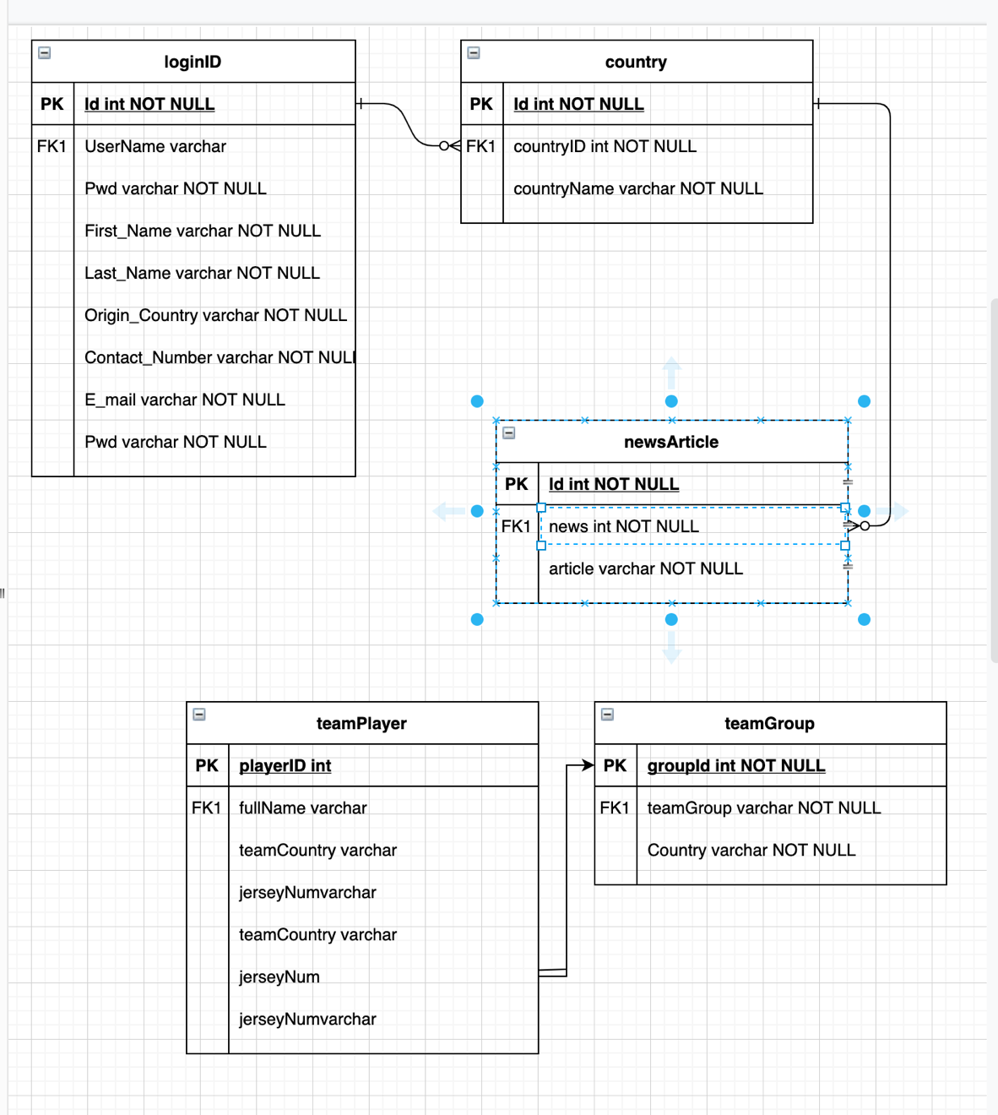

5.2 Use Case

The use case for this project report is a description of a specific goal or task that a user wants to achieve using a system or software. It provides a clear understanding of the steps involved in completing a specific task, as well as the outcomes and benefits to the user.

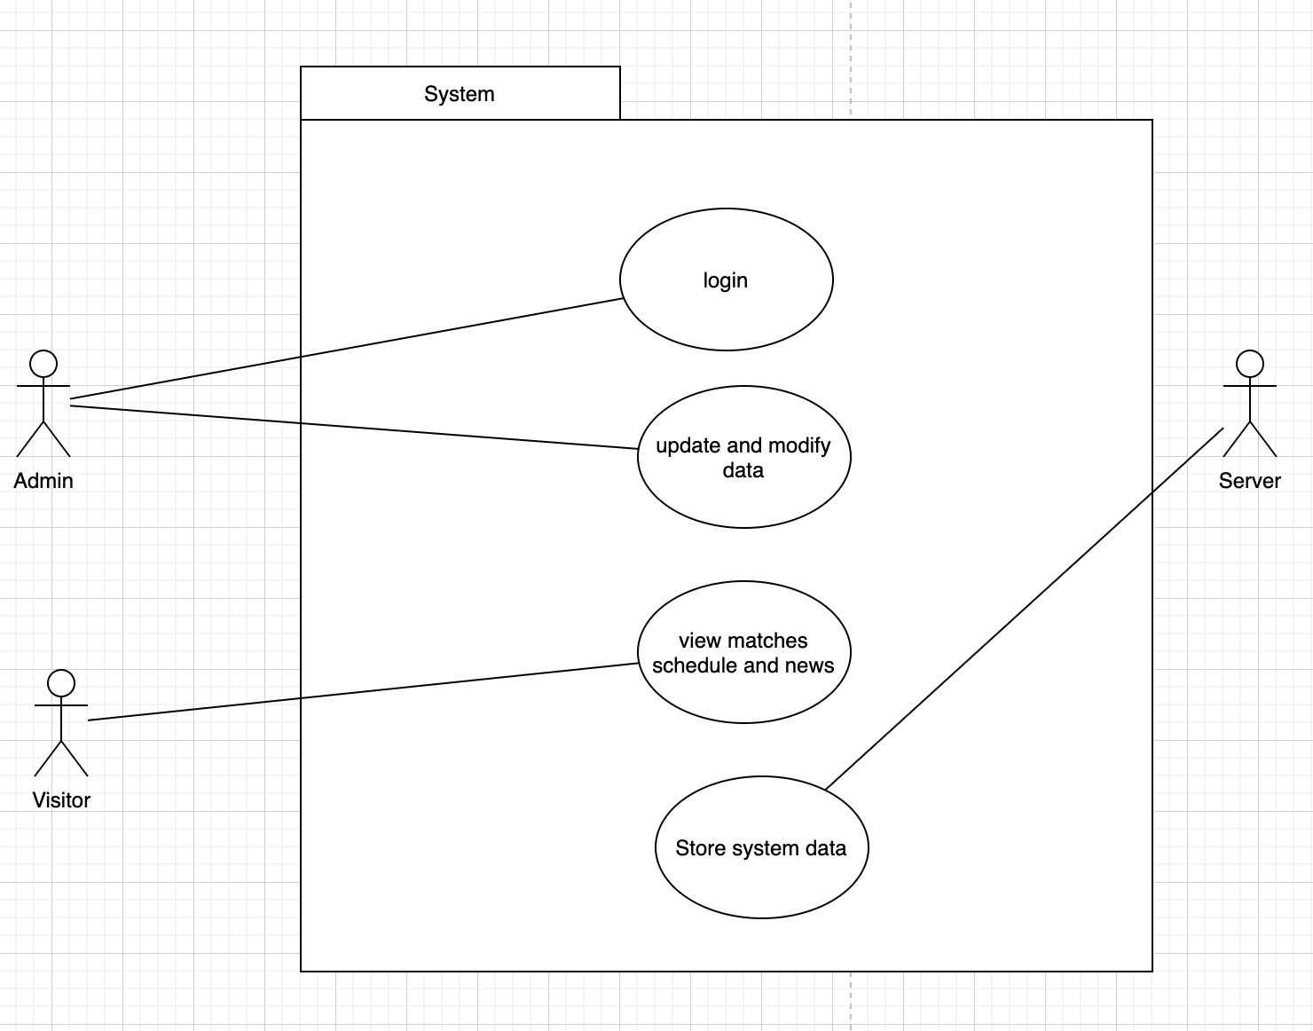

5.3 Activity Diagram

The system’s activity diagram in a project report is a graphical representation of the flow of activities involved in completing a specific task or achieving a goal within a system or software

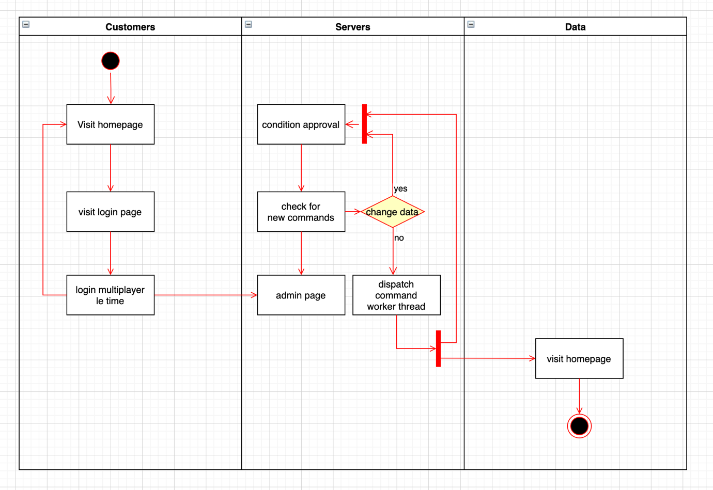

6.0 Source Code

1. Web.config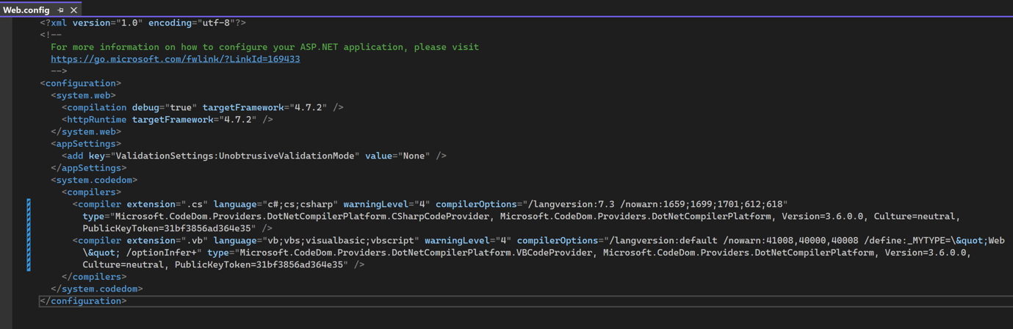
2. Homepage

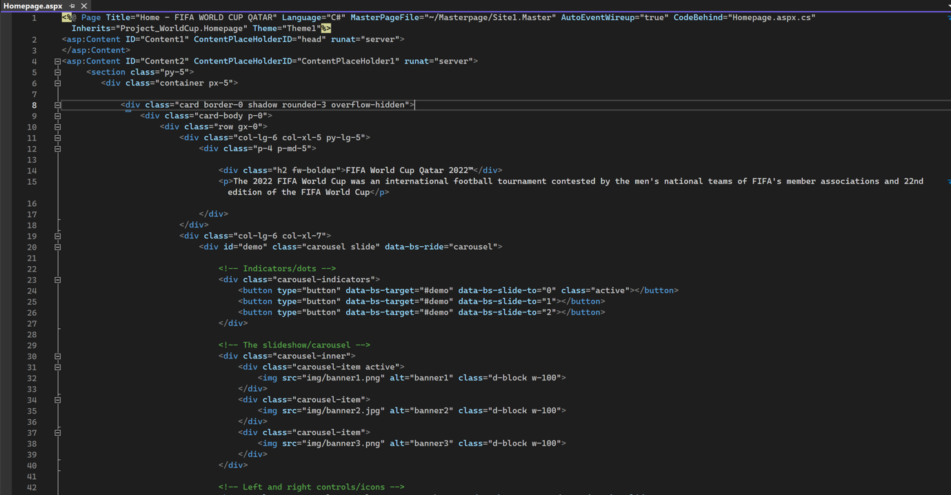

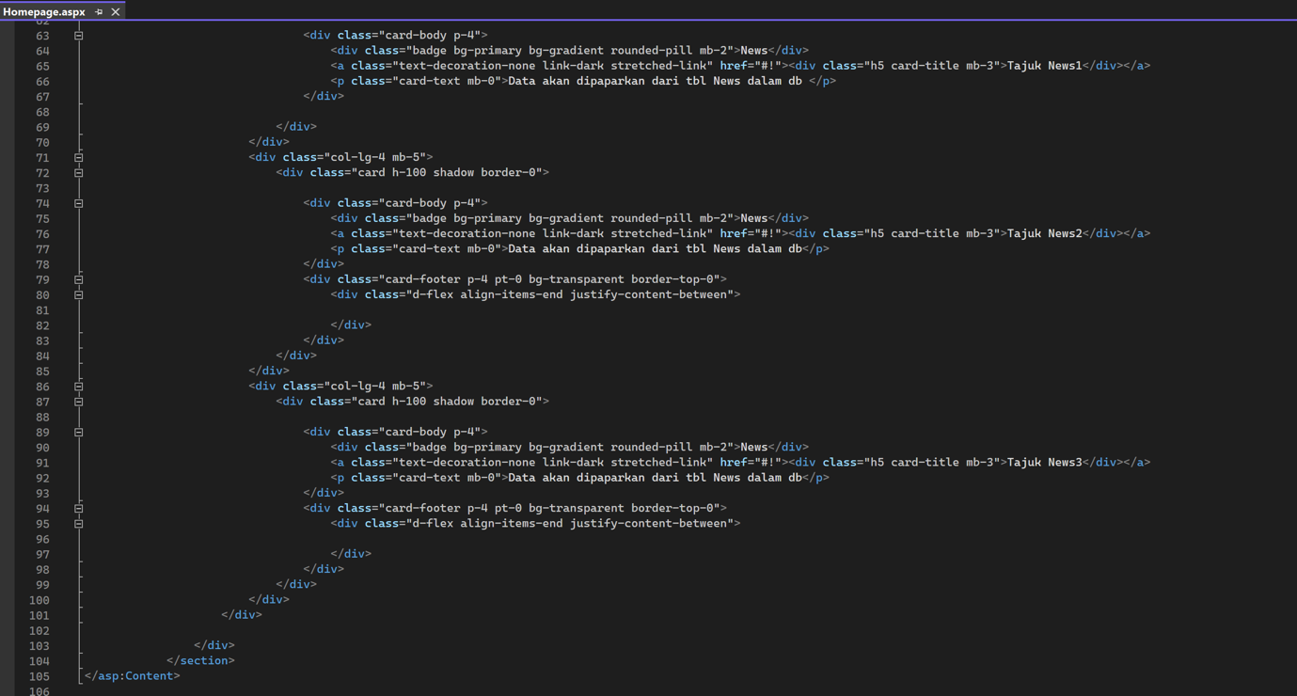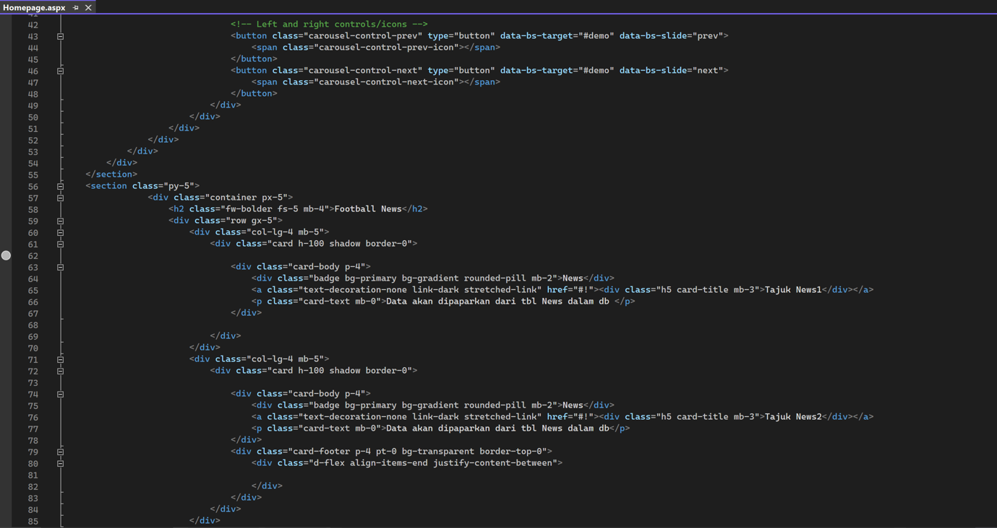

1. Group List Team page

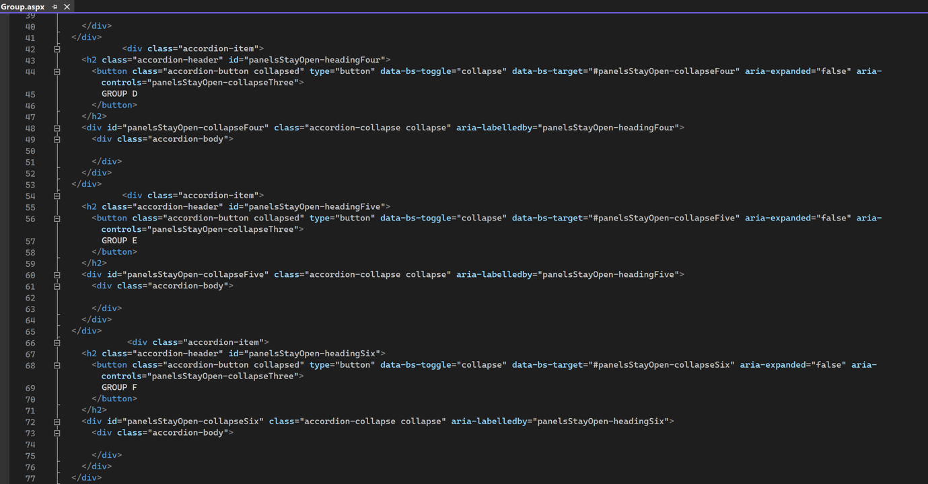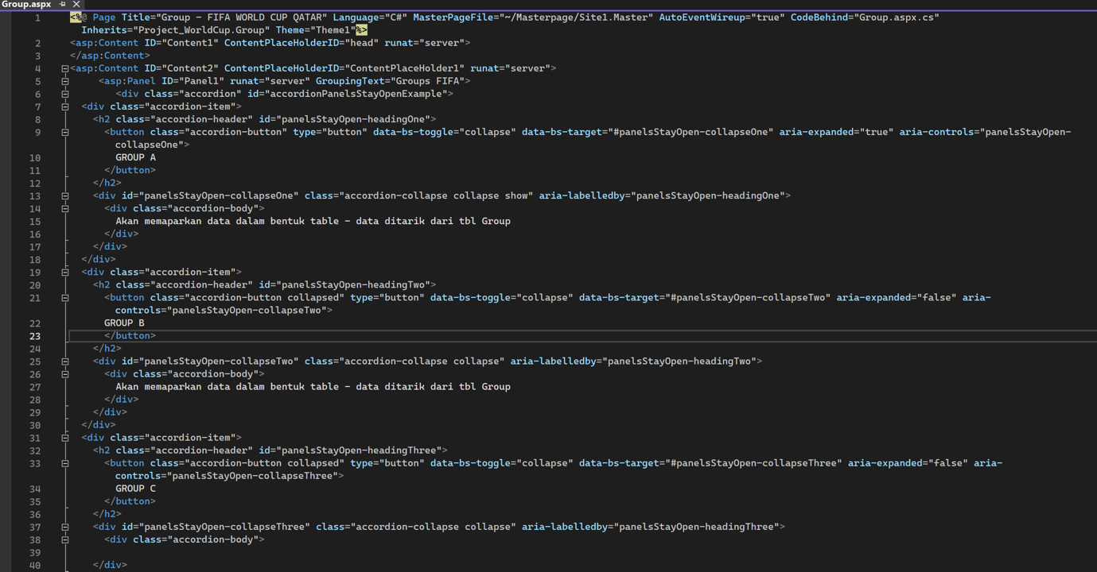

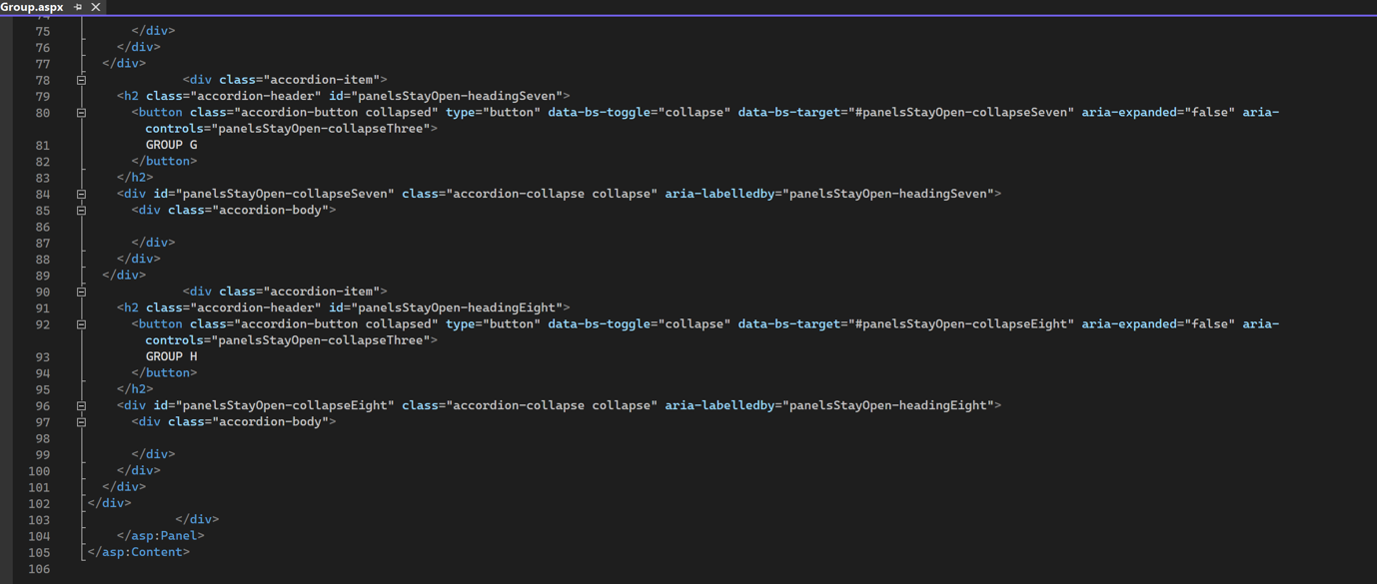

4) Players page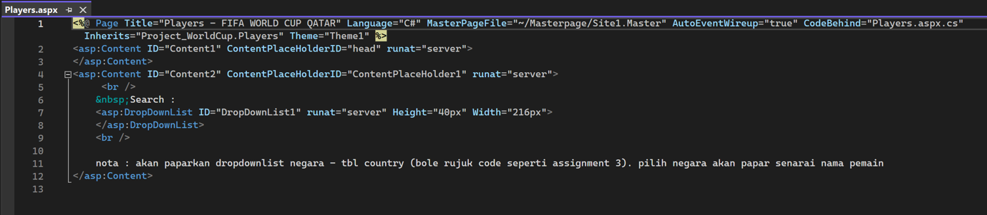

1. 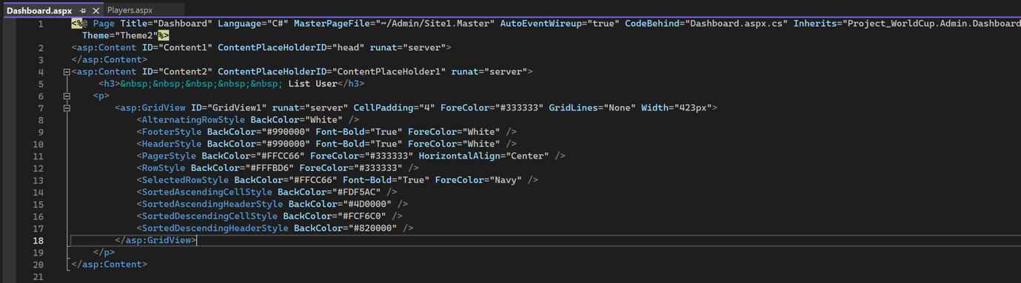Dashboard page

6) Login page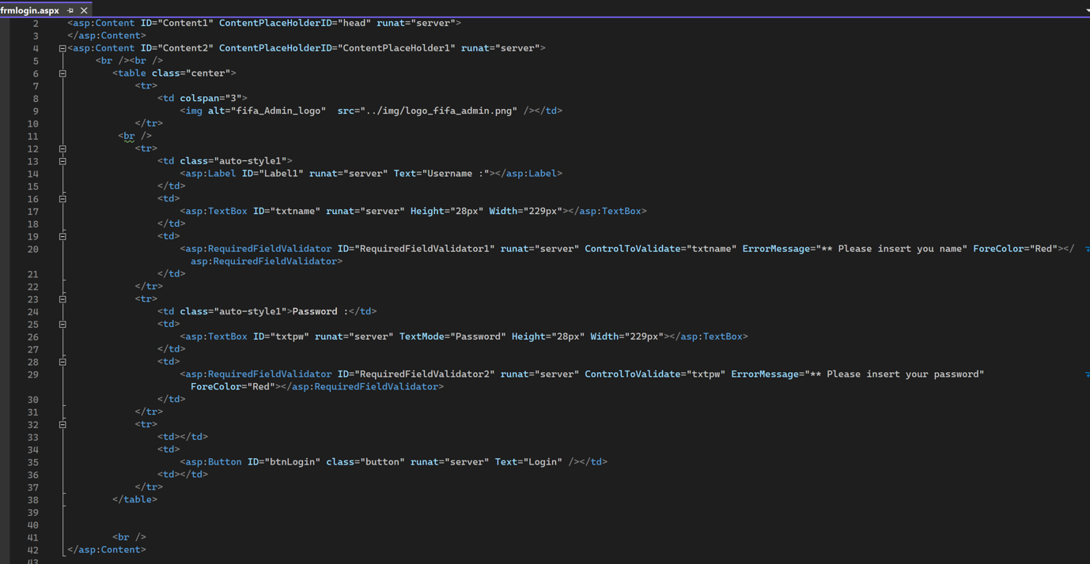

7) Add user page for login purpose

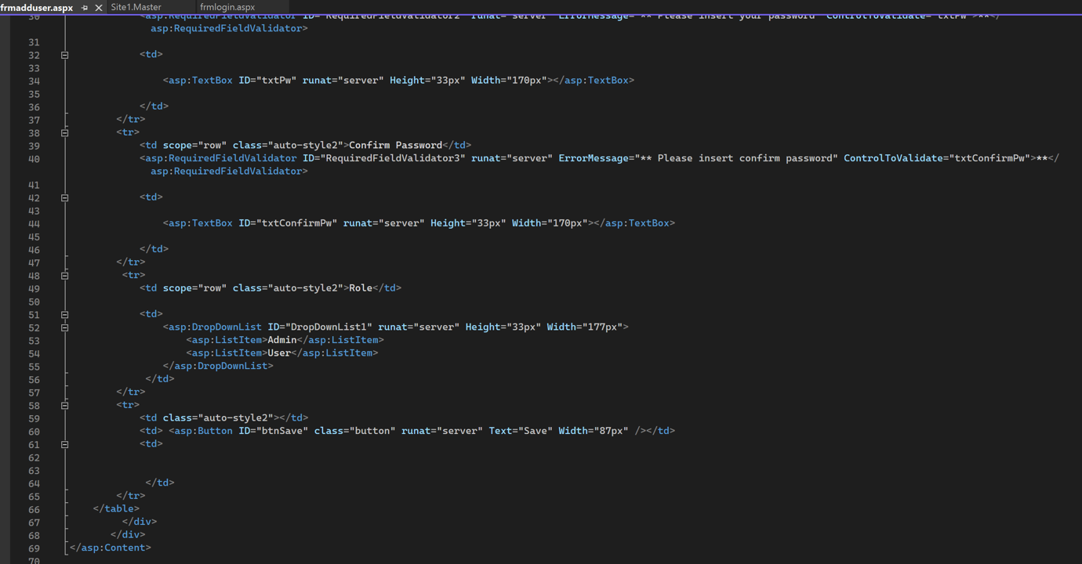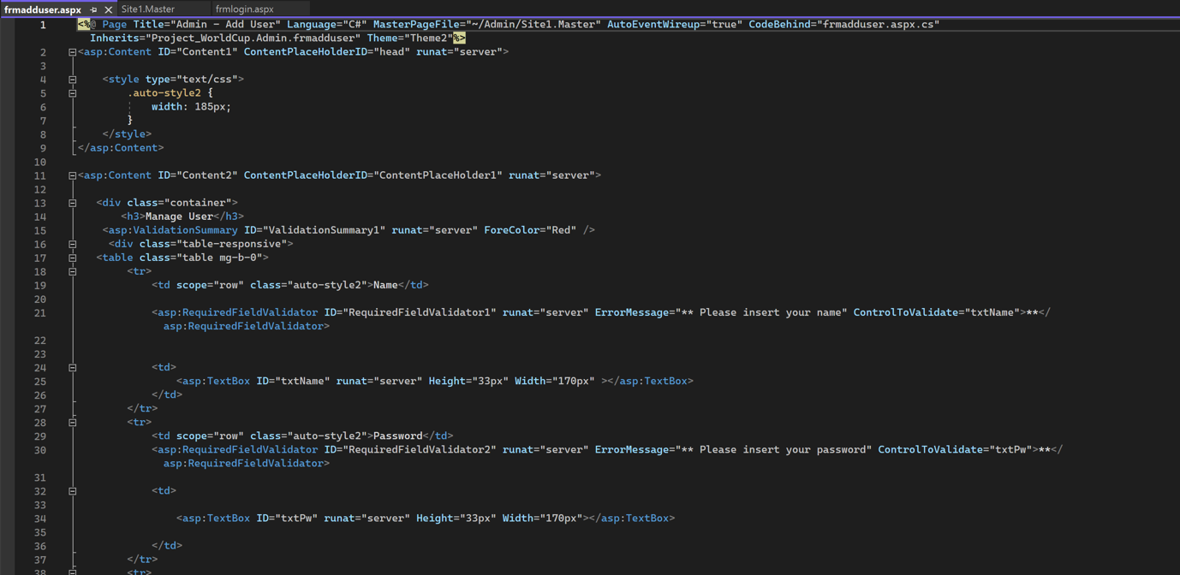

8) Masterpages is required to facilitate the pages for admin

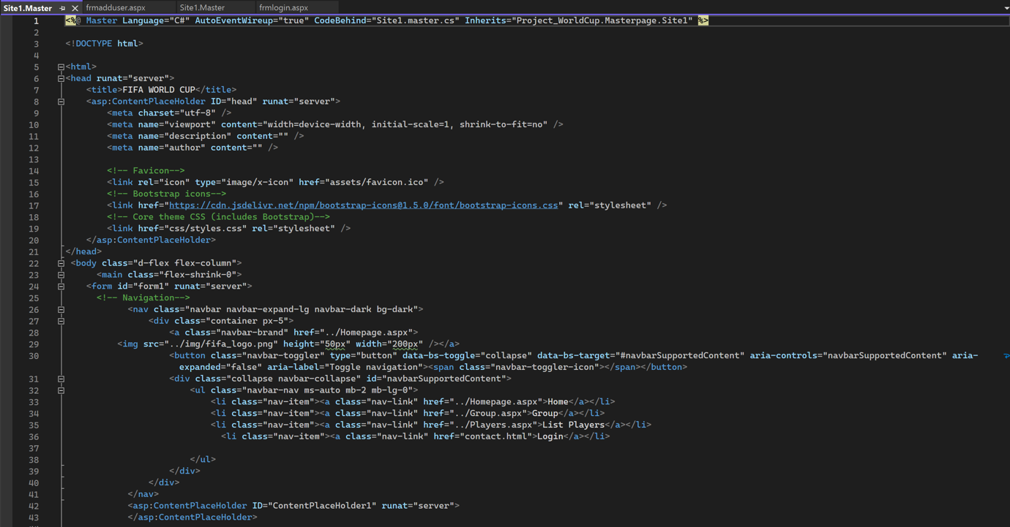

7.0 Interface Design

Our design principles outline the interfaces for each modules which focusing on the aim of providing a comprehensive and engaging platform for visitors to follow-up and experience the tournament while keeping it simple

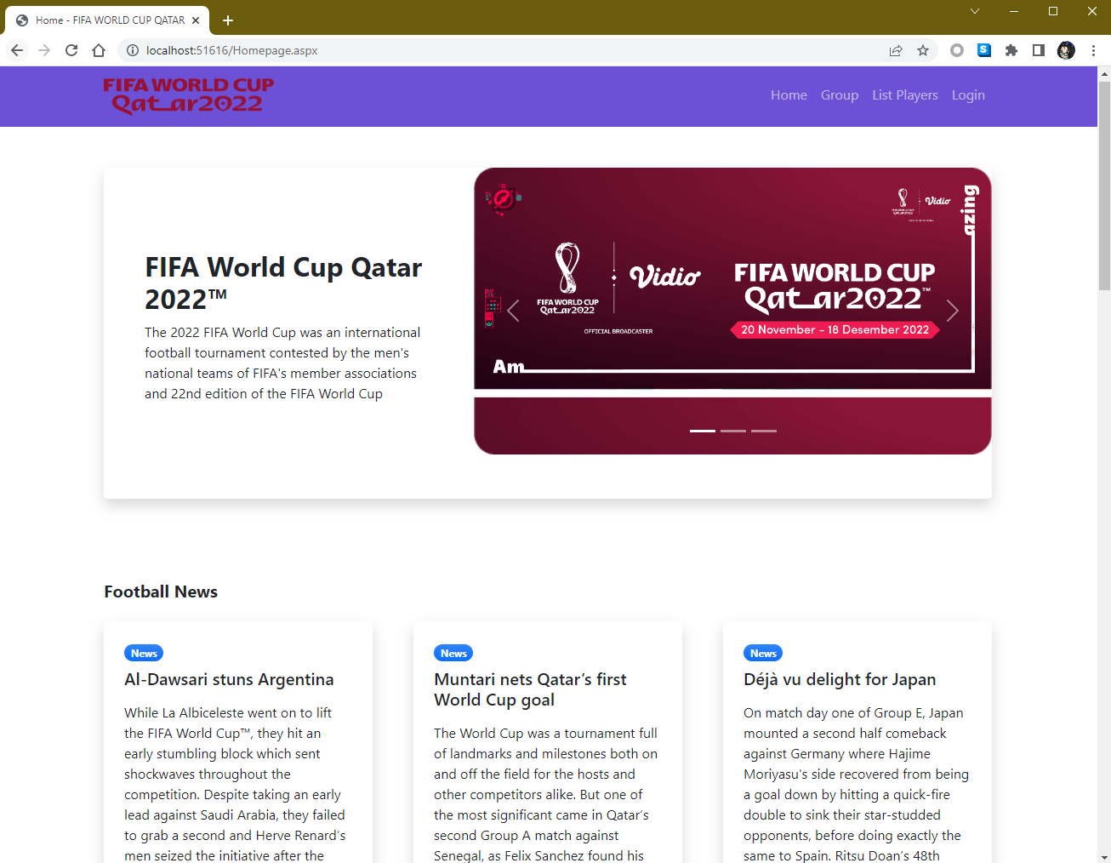7.0.1 For our homepage interface, the homepage of the website is the first point of contact for visitors and serves as a getaway to the rest of the website to provide a simplistic yet engaging with visitors.

7.0.2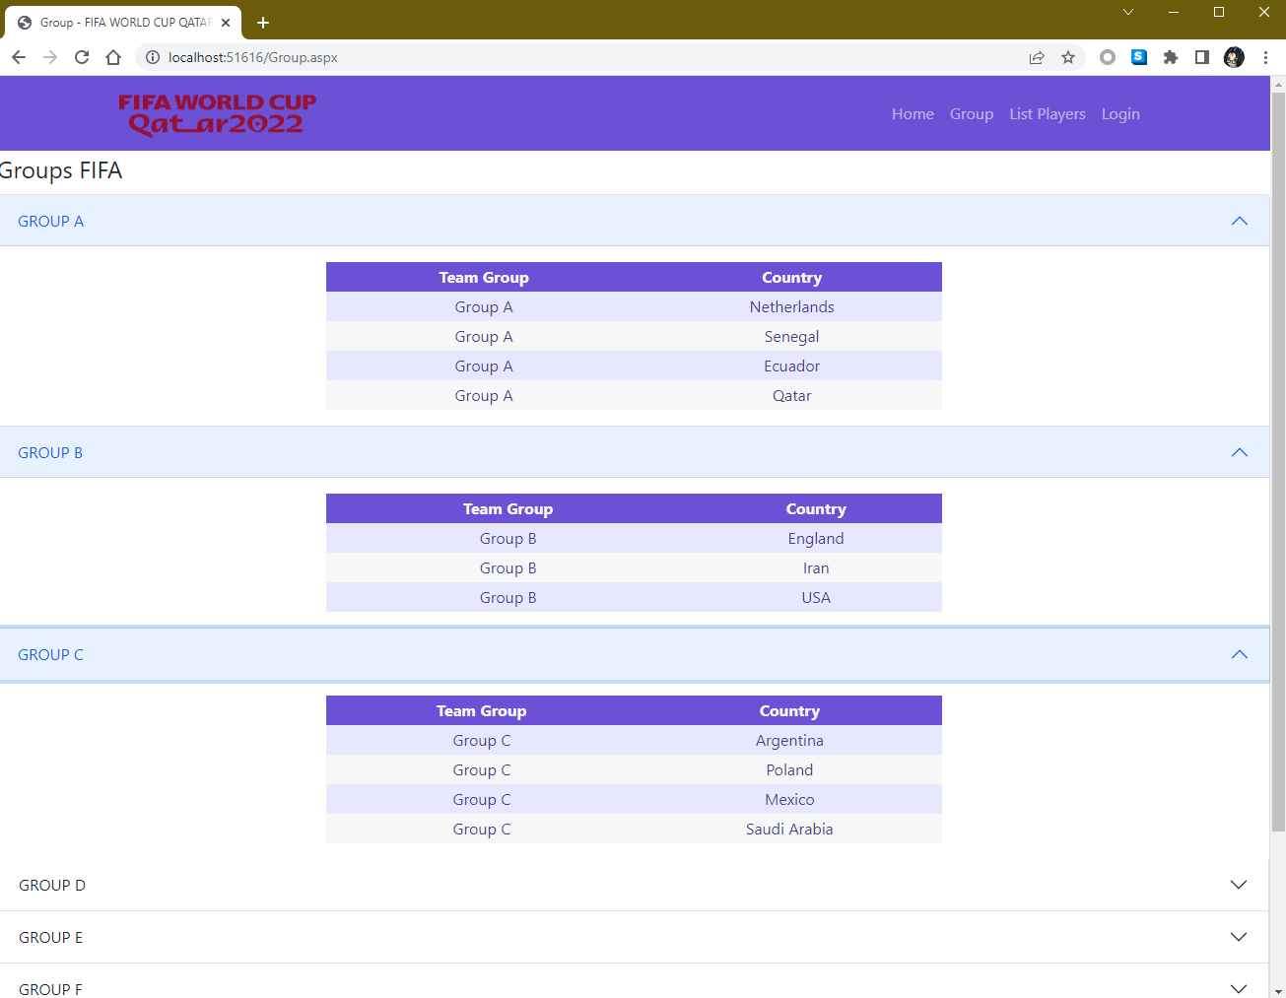 Below is the preview of Group team players page which containing team names, countries and group name to display the matchup of grouping tables for each teams.

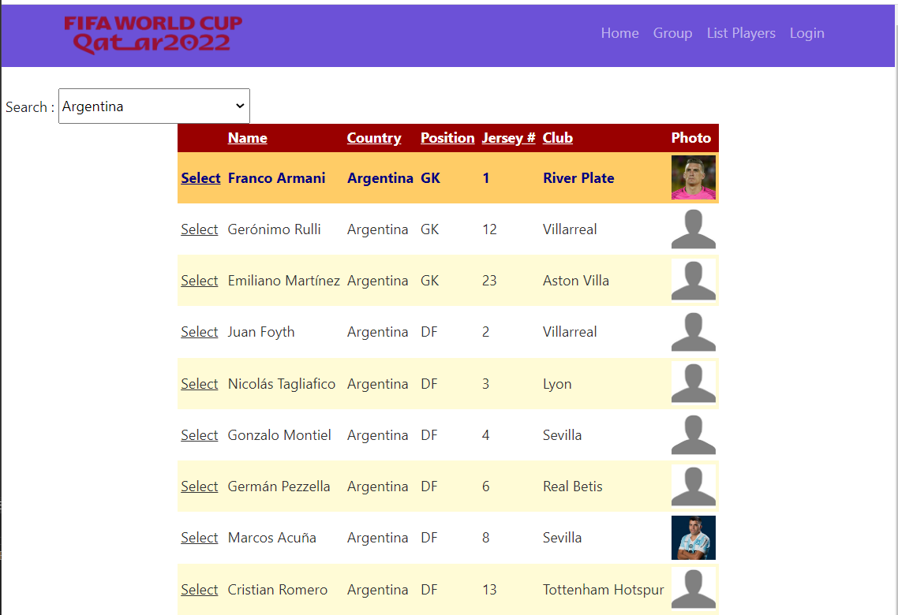7.0.3 Player list search

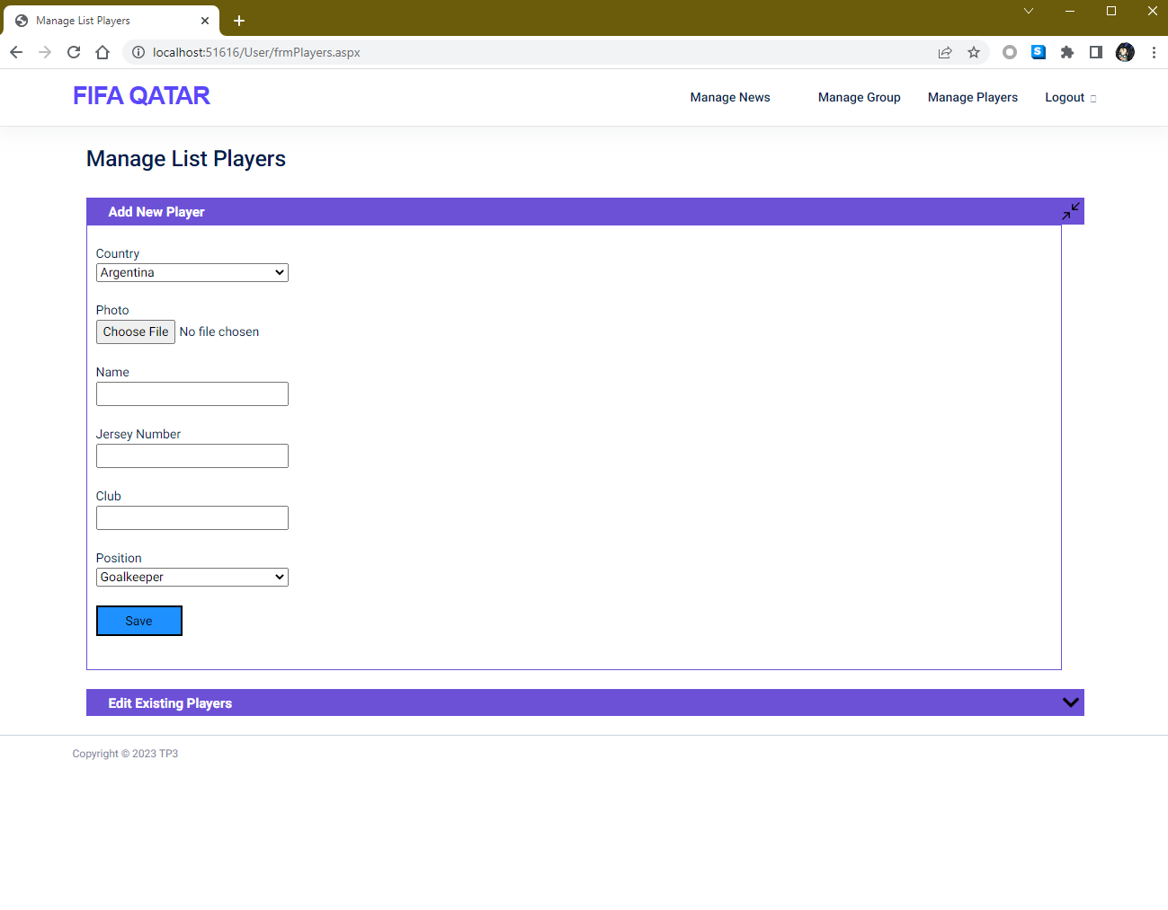

7.0.4 Manage List Players

7.0.5 Group Team Management page

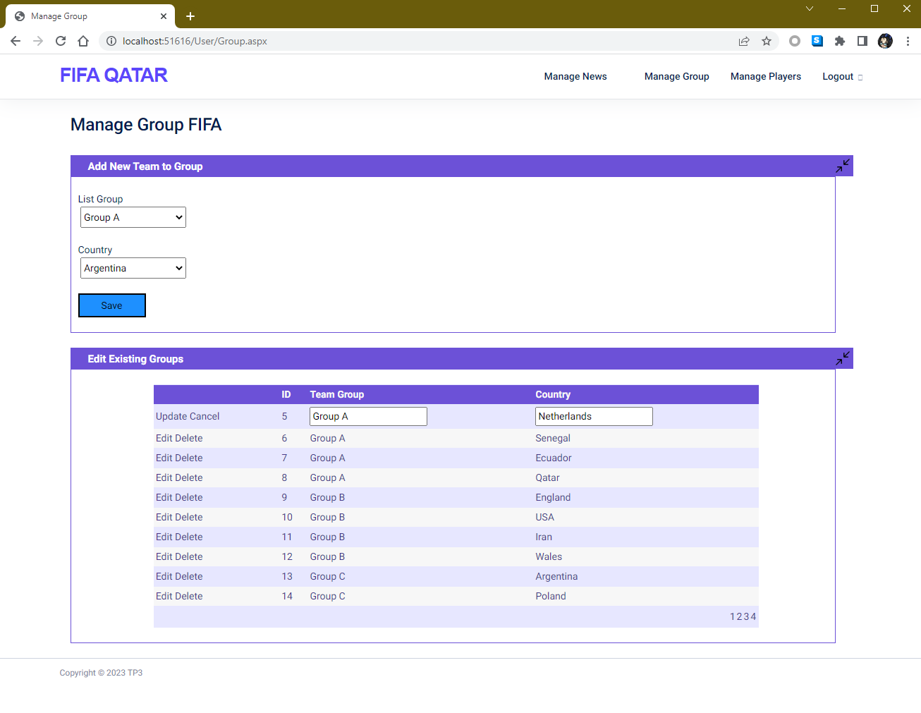

7.0.6 Dashboard admin page

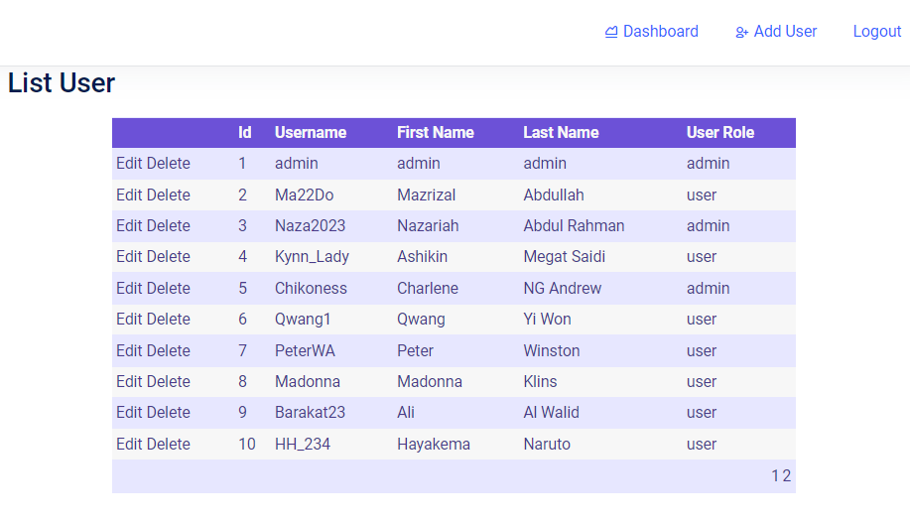

7.0.7 Manage user page for admin.

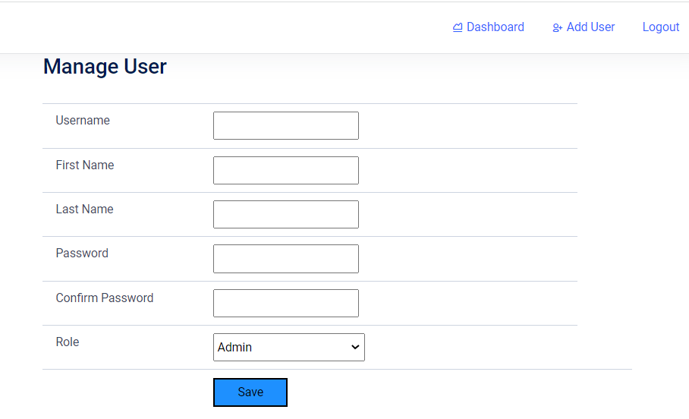

7.0.8 Manage News page for admin

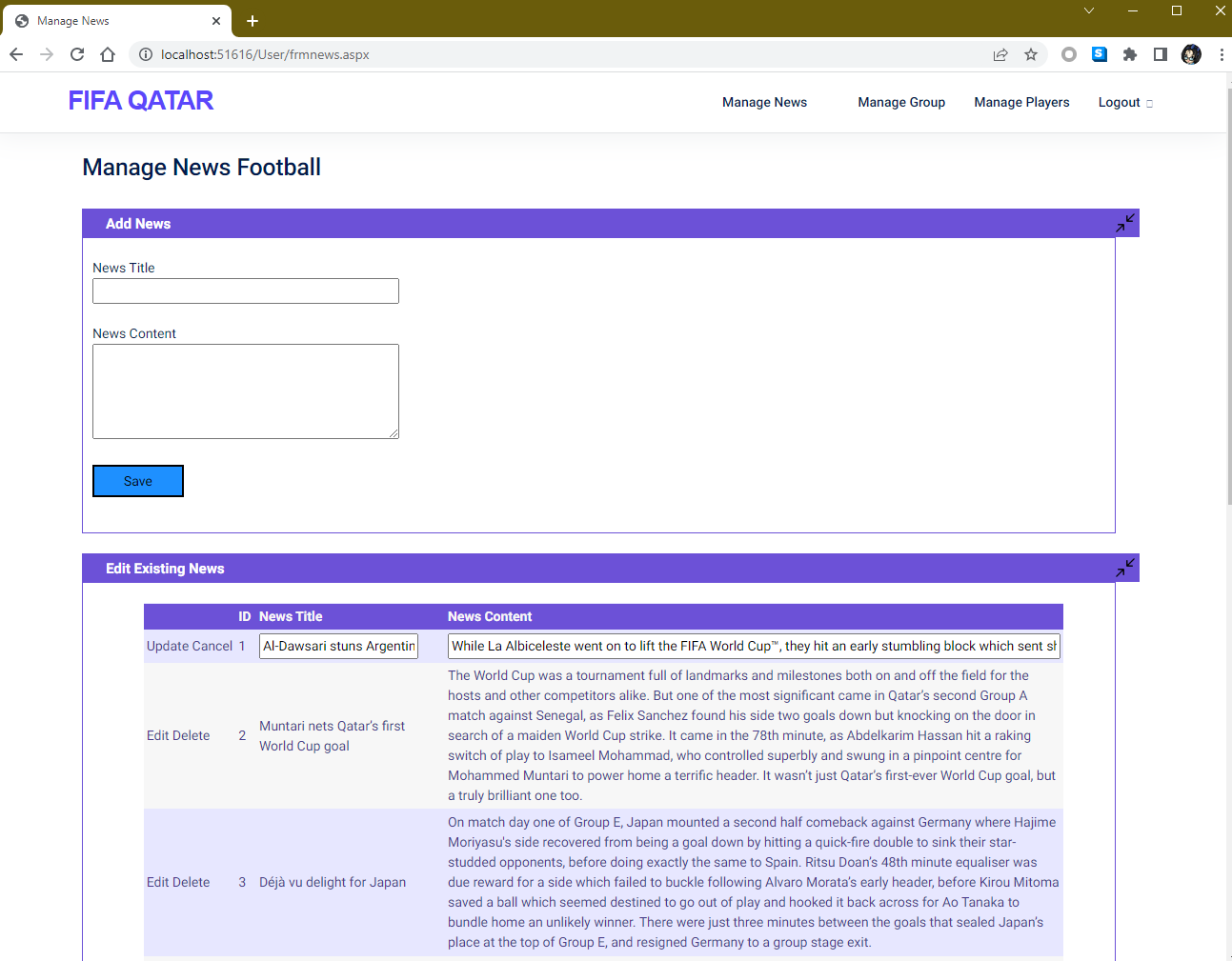

7.0.9 Login page

